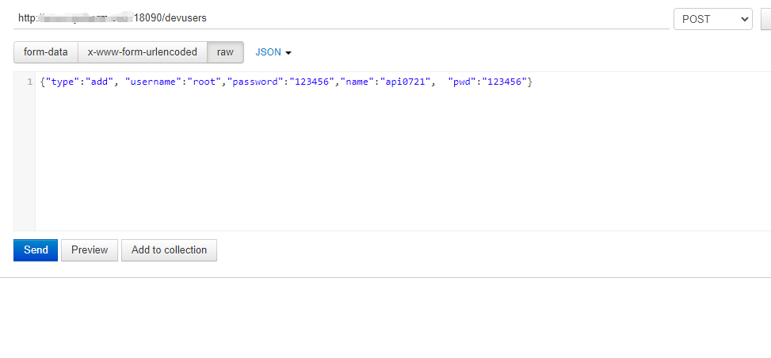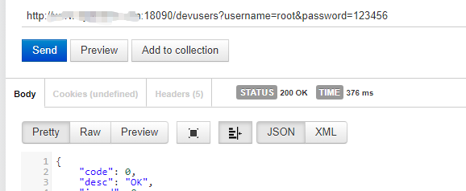

设备用户api
添加api： {"type":"add", "name":"**", "pwd":"***", "parent_name","不必填", "customize":"不必填", "remarks":"不必填"}
删除api： {"type":"delete", "id":**, "name":"**"} 备注：id，name有一个必须有值
修改api： {"type":"modify", "id":**, "name":"**",} 备注：id，name， mac有一个必须有值，支持修改的字段 "customize"，"reg_expries"，"port_allocation_mode"， "port_hold_time""http_img_port"，"upload_cdr"，"upload_sms"，"updata_call_status"，"upload_media"，"timing_start_date"，"remarks"

